S
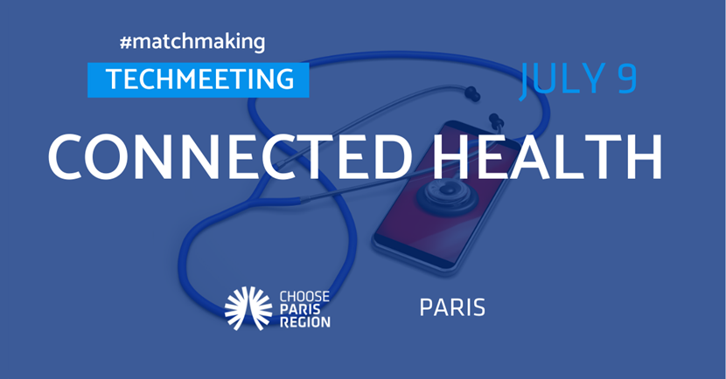
Who’s attending?
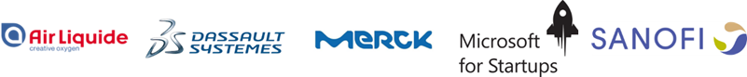

And more coming soon…
Are you developing innovative solutions in Connected Health?
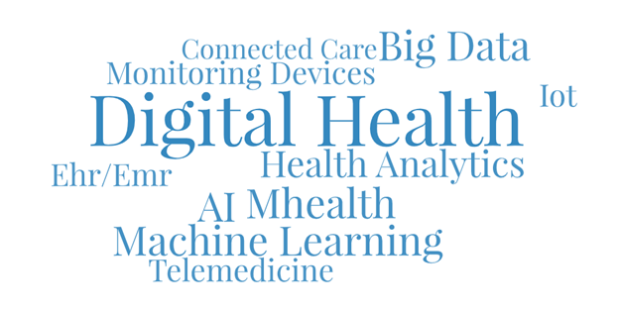
Connecting Large Corporates with the Startups They Need to Succeed
A unique opportunity to present your solution to different large corporations dedicated to the theme and benefit from high-level connections

“The Choose Paris Region team will support you before, during and after the TechMeeting to ensure a successful networking experience!”

REGISTER
Deadline for applications: June 23, 2020

More information here
Follow us
#TechMeet

Nadia Zaïdi  Corporate Innovation Manager | +33 (0)1 75 62 58 52  +33 (0)6 95 51 97 75  nadia.zaidi@chooseparisregion.org
__________________________________________________________________________________________
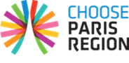 | 11 rue de Cambrai  Bâtiment 28  75019 Paris - France | Paris - San Francisco - New York - Los Angeles - Beijing - Shanghai  
__________________________________________________________________________________________

