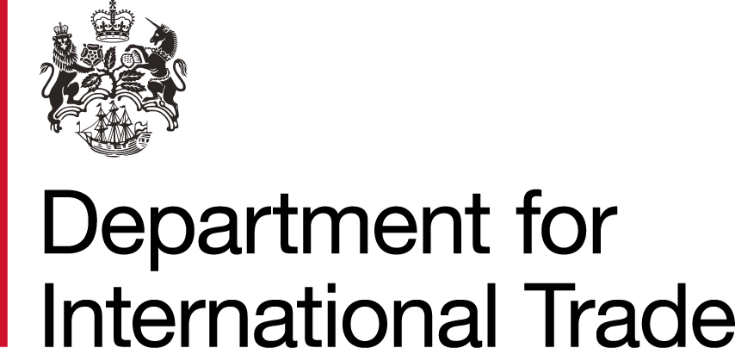



Virtual Industry Day
Central Europe

This Border and Protocol Delivery Group Virtual Industry Day will cover border formalities between the EU and GB at the end of the Transition Period in detail including operational case studies.

The UK's Border and Protocol Delivery Group (BPDG) and the Department for International Trade (DIT) invite industry bodies, hauliers, traders and government officials from Central Europe to join this Virtual Industry Day on GB-EU border procedures including customs, VAT and excise, sanitary and phytosanitary (SPS) requirements and controlled goods, and UK traffic management.


Following introductory remarks by Richlove Mensah, DIT's Regional Director for Trade and Investment in Central Europe, officials from HM Revenue & Customs (HMRC), Department for Environment Food & Rural Affairs (Defra), Food Standards Agency (FSA) and the Department for Transport (DfT) will present the latest information you need to know.

Join us and find out what you need to know to keep your business moving after 1 January 2021.

Date
16 November 2020

Time
11:00 - 13:00 CE Time
10:00 - 12:00 UK Time

Price
Free


Register
Now

